The Villains’ Virus Worksheet

**Course:** SuperheroSTEM:

**Materials:** A pencil and paper, and your imagination 🚀

**Created by:** Ryan Saelens

1620de04-dbca-4234-acf4-bad827ee856e.png

**MISSION BRIEFING:**

**A TEAM OF** **VILLAINS HAVE HACKED** into the **Superhero HQ Database!** They’re looking for **special files** regarding **magical items,** which the **heroes have been the protectors of for ages!**

The villains are relentless**--**they will stop at nothingto **obtain the magical items, to then take over the world with...GO FIGURE!**

**How ever will they be stopped?**

**YOU** are a **Cyber-Scientist 🡪 CS for short ☺**

**YOUR MISSION** is to help **keep ANY SECRET INFORMATION in the database protected, especially** anything pertaining to the **MAGICAL ITEMS!**

**It’s important that the villains don’t gain access to these files!**

**REMEMBER,** you’re working **WITH the heroes, AGAINST the villains!**

**SKILLS TO MASTER:**

* **🗣 Build** Narrative
* **🗂 Create** Folders
* **🔒 Encrypt** Files
* **🛡 Protect** Important Info
* **🎯 Create** Fake "Distractions"
* **🧠 Use** Clever Misdirection

**LEARNING GOALS:**

* **Learn the difference** between **encryption** and **password-protection.**
* **Develop** **critical thinking, storytelling, and world-building** **skills** to **create a believable world** that protects important information.
* **Learn** basic ways to **store and secure** information on a computer.
* **Understand** why **protecting** **information** is important.
* **Understand** how to **use misdirection to protect** sensitive information.

So, **WHAT** is **ENCRYPTION?** And **WHAT** is **PASSWORD-PROTECTION*?***

* **Encryption** = **Locking** the file and **scrambling it** so villains **can't read it,** **even if they steal it.**
* **Password Protection** = Putting a **lock on the file**, but if they **pick the lock (easy for villains!),** they can still read it.

Module 0: start your story!

**Before you begin** creating and protecting information, you’ll need to **create the story** behind **WHY** the villains are **hacking the Superhero HQ Database!**

Below are a few questions to **help get you started:**

* A cartoon of a joker punching a boxing glove

  Description automatically generated**Who** are the **villains?**
* **Who’s** on your **team of heroes?**
* **Why** are the villains wanting to **take over the world?**
* **What** importance do the **magical items have?**

**GET CREATIVE WITH IT** **AND HAVE FUN!**

Module 1: Create your database!

Start by creating a **MAIN FOLDER!**

* **THIS FOLDER** will be the name of your **DATABASE!** 
  + Give it a cool **code name** (examples: **"The Infinity Archives"** or **"Quantum Vault"**, maybe something like **“The Storage of Secrecy”**).
* Be sure to **TAKE NOTES** **(whether WRITTEN or TYPED in a text document)** to make sure you **DON’T FORGET THINGS!**
  + It’s very important to **store passwords** and other information, somewhere **(safe).** 
    - **Imagine encrypting a bunch of files**--files that you spent time on **(perhaps a text file with certain secret information)** **BUT** you **cannot remember the password,** so you **cannot access it.**

Module 2: Assemble your hero team!

**Now,** you will start to **fill the DATABASE FOLDER!**

* Inside your **DATABASE FOLDER,** create **4–7 folders,** one for **each hero** you choose!
  + Mixing universes is **highly recommended!** 
    - **Example Team:** Sonic, The Hulk, Dr. Manhattan, Spider-Man, and Naruto!
* **Give each hero a fun** **code name** **too!**
  + Something that will **make the villains scratch their heads!** 
    - Something that **you can remember,** though **if you forget,** it’s okay, because **you’re taking notes, right?** 🙂

Module 3: Fill your Heroes’ Folders!

**Next,** you will spend time **filling the HERO FOLDERS!**

* Inside **each hero's** **folder,** **do any (or all) of the following:** 
  + **SEARCH** and **SAVE** **2–3 fun images** about the hero! Make sure to **save them to the right folder! Some examples are below to help get you started:**
    - Favorite Food(s)
    - Favorite Sport(s)
    - Pet(s)
    - Hobbies
    - Silly Fact(s)
  + **CREATE FAKE FOLDERS** with **important sounding names!** 
    - They can have **unimportant files inside,** or **nothing at all!** **Your choice!**
    - This is to **make the villain think the folder is important, when really, it’s not!** 
      * This is called ***misdirection*,** and it’s a **wonderful skill for a Cyber-Scientist** to have!
  + **CREATE TEXT DOCUMENTS** with **clever names,** and **fill it with unimportant information,** or again, **nothing at all.** **Your choice!** 
    - The **goal** is to **make the villain think it’s important!** 
      * **A robot with red eyes

        Description automatically generatedExample:** Text document named **“Important Secrets of Science”,** but when the villain opens it, **it’s just a text file with a picture of a hot dog and a bit of text that says,** **“Did you find what you were looking for?”**
    - **If you create a text document,** make sure you **save it inside the correct hero folder!**
  + **CREATE WEBSITE SHORTCUTS** with **WHATEVER** **names you want!** 
    - **A person sitting at a desk working on a computer

      Description automatically generatedThink of websites that the hero may visit!** 
      * **Keeping it appropriate of course 🙂** 
        + **Example: “The Flash”** or **“Sonic”** may visit **shoe websites because they like to run. “The Guardians of the Galaxy”** would most likely **visit sites of companies such as NASA or SpaceX!**
    - **You can also create shortcuts to websites that don’t work!** 
      * **Example: Open an internet browser tab** and in the **top search bar, type a bunch of random none-sense** and **CLICK ENTER!** This will more than likely, **load nothing.** 
        + You can then **CREATE a shortcut** and **SAVE it** to the **correct hero folder!**
  + **NOTE:** These are files that would **NOT HURT** the heroes if a **villain found them.**

Module 4: Protect the magical secrets!

**Lastly,** we want to **add important files about the magical items,** and then **protect them by adding encryption!**

* Still inside each hero’s folder, **do the following:** 
  + **CREATE** **2–3 important secret files** that are about the **magical items** 
    - Then **save them** in the **correct hero folder!**
    - **Examples:** 
      * **Images** (Drawings or Blueprints, Places Item Has Been Seen)
      * **Text Documents** and **Website Shortcuts** (Fake "Data Files,", Location Information files, Etc.)
        + **Think about what you did in the last module and** **APPLY THINGS** to this module! **REMEMBER,** **these files are important!**
  + A green circle with a white padlock on it

    Description automatically generated**ENCRYPT** or **PASSWORD-PROTECT** **important files!** 
    - **TO ENCRYPT:** 
      * **RIGHT-CLICK the File/Folder you wish to encrypt**
      * **SELECT “Properties”**
      * **NAVIGATE to the “General” Tab**
      * **CLICK “Advanced”**
      * **CHECK the “Encrypt contents to secure data” box**
      * **CLICK “Okay” and “Apply”**

* + - **TO PASSWORD-PROTECT:** 
      * **MUST BE MICROSOFT DOCUMENT (offers password for files)**
      * 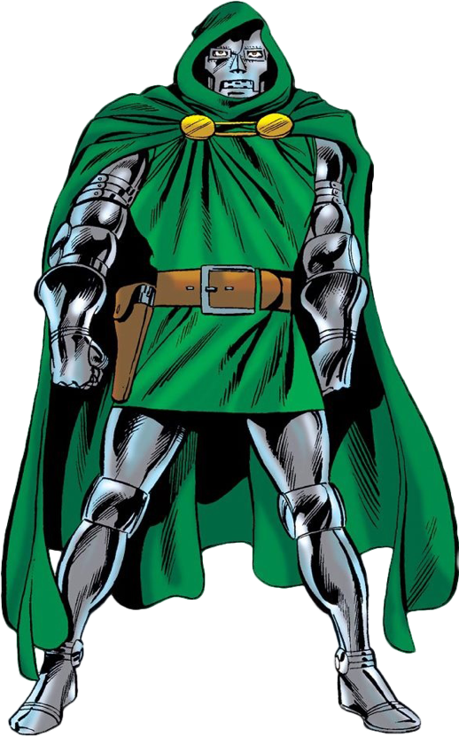**OPEN the Microsoft file** you wish to **password-protect** 
        + This can be a **Word file, a PowerPoint Presentation, Excel File, Etc.**
      * **Example using Word:** 
        + **Open** document in **Microsoft Word**
        + **CLICK “File” (top-left corner)**
        + **CLICK “Info”**
        + **CHOOSE “Protect Document”** button
        + **CHOOSE “Encrypt with Password”**
        + **TYPE** a password you want, **CONFIRM** it, **SAVE** it!

**Be sure to store passwords in a safe place (notebook that only you know about)**

**CONGRATS! You’ve** **added encryption and passwords** to your files!

**NOTE:** If you try to **encrypt an entire folder,** you will be asked if you wish to **encrypt all the folders or files inside**, so just **be careful** with what you **ACTUALLY** want to encrypt.

**\*\* Encrypt each file before moving on to the next one!** You **don’t want to forget** which files you **want to add protection to.** Best way to do this is to **protect as you go!**

** **This is to make things easier on you,** unless of course you’re **writing down the files that are important and those that are not so important, to encrypt later. (HINT: YOU SHOULD BE! 🙂)**

**QUICK CHECKLIST:**

**REMEMBER,** you don’t have to include everything below. **BUT** the more you **do include,** the **harder it will be for villains to steal important information! Check what you included in your DATABASE FOLDER, below:**

* 🔎 **Searched and saved** fun images
* 📂 **Created** fake folders
* 📄 **Made** funny text documents
* 🌐 **Built** website shortcuts
* 🔐 **Encrypted** important files
* 🔐 **Password-Protected** important files

**The Idea:**   
 If the villains **snoop through the heroes' folders,** they **find some harmless fun stuff,** but if they **find the real secrets,** they **can't open them without the right password!** 😎

**After you’re done,** you’ll be able to **PRESENT YOUR DATABASE** with the **rest of the class!**

**📚 QUICK GLOSSARY:**

**Encryption**   
 → Locking a file and scrambling it **so nobody can read it without the special key.**

**Password Protection**   
 → Locking a file with a password **— but if someone guesses or hacks the password, they can still open it.**

**Database**   
 → A special place (folder) where you store **and organize important files and information.**

**Misdirection**   
 → Tricking villains into thinking **something is important... when it’s not!**

**Cyber-Scientist (CS)**   
 → Another name for a **Cyber Security Specialist!**

**Shortcut**   
 → A small file that quickly takes you to a website **or another file when you click it.**

